ST 352

**Lab Assignment 8**

***16 points***

***Due 11:59 PM on Friday, December 6***

Recently, you participated in a “memory game” activity. In this assignment, you will answer this question of interest: ***“Is there an association between the type of person one considers themselves (morning or evening) and how many items were remembered?”*** Use the **memorygame** data set posted on Canvas to answer this question of interest.

* Note: the number of items remembered is categorized into two groups as defined below.

There are two columns in the data set:

* **pctremember**  *(“yes” = remembered at least 60% of the items, “no” = remembered less than 60% of the items)*
* **type** *(evening person or morning person)*

Answer the following questions. The output and graph obtained in the Lab 8 Notes will be helpful in answering some of these questions.

1. ***(3 points)*** State the null and alternative hypotheses in statistical notation AND words. Define the notation in the context of the problem.

$H_{0}:p_{evening}=p_{morning}$**or $H_{0}:p_{evening}-p_{morning}=0$**

*In words: There is no association between whether or not at least 60% of the items were remembered and type of person (morning or evening).*

$H_{A}:p_{evening}≠p_{morning}$**or $H_{A}:p_{evening}-p_{morning}≠0$,**

*In words: There is an association between whether or not at least 60% of the items were remembered and type of person (morning or evening)*

**where $p_{evening}$ is the proportion of who remember at least 60% of the items for evening people and $p_{morning}$ is the proportion who remember at least 60% of the items for morning people**

**+0.5 for using correct notation (i.e. using a p and not $\hat{p}$ or µ)**

**+0.5 for defining notation in the context of the problem**

**+1 for stating each hypotheses correctly in notation**

**+1 for stating each hypothesis correctly in words**

2. ***(2 points)*** Construct a table of counts that also includes appropriate comparison proportions. In the Lab 8 Notes, you obtained a table of counts and a proportions table. **Do not copy and paste these tables here.** Rather, use the table you obtained to present a “nicer-looking” table of counts that will contain the counts and appropriate comparison proportions in each cell. (One way to do this is to put the proportions in parentheses below each count in your table.)

*Type of person*

**Remember ≥ 60%? Evening morning total**

No 87 20 107

(0.7131) (0.5000)

Yes 35 20 55

(0.2869) (0.5000)

Total 122 40 162

**+1 for table including both counts and proportions. (Tables could be separate or combined)**

**+0.5 points for including labels in correct order.**

**+0.5 points for properly using column totals in the calculation of the proportions**

***Note: row and column totals do NOT have to be included in the table of counts***

***Note 2: student can report percentages in table instead of proportions – either is fine***

3. ***(2 points)*** In the Lab 8 Notes, you constructed a side-by-side bar chart with a legend. Copy and paste the graph here.

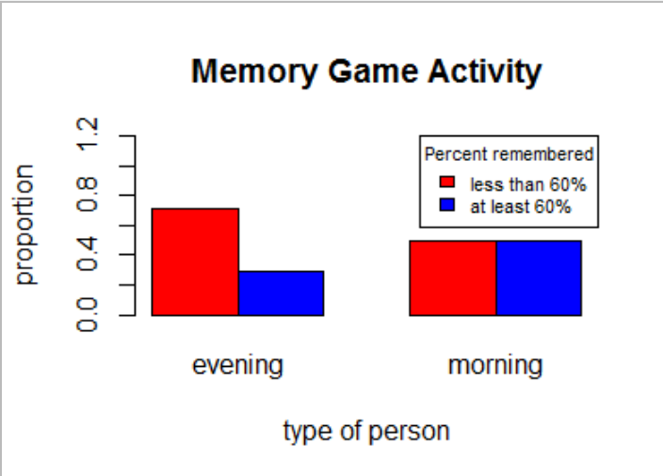

**+1.25 for correct graph**

**+0.5 points for legend (appropriately labeled)**

**+0.25 points for correctly labeling axes and giving graph a title**

4. ***(2 points)*** Based on the comparison proportions and/or the side-by-side bar chart, does it appear that the proportion remembering at least 60% of the items is different between those who consider themselves morning people and those who consider themselves evening people? Briefly explain.

**Answers could possibly vary a little, but it is pretty evident from comparing the sample proportions that the proportion remembering at least 60% is different between “evening” and “morning” people. In addition, the side-by-side bar chart shows a different relationship between connected bars, which is also an indication that an association may exist between proportion of items remembered and type of person. Look for support when grading.**

**+1/2 for saying whether they think proportions are different or not.**

**+1.5 for explanation.**

With a categorical response and explanatory variable, each with two categories, there are two hypothesis tests that can be used to answer the question of interest. For this problem, use the chi-square test for association.

5. ***(2 points)*** Is the condition satisfied to use the chi-square methods to perform the Test for Association? Explain.

**Yes! All expected counts are at least five. (Table below does not need to be included)**

evening morning

no 80.58025 26.41975

yes 41.41975 13.58025

**+1/2 for saying “yes”**

**+1.5 for proper support (if use observed counts instead of expected, take off 1/2 point. If use some other value besides “5”, take off 1 point)**

6. ***(2 points)*** Report the chi-square statistic with degrees of freedom.

$χ_{1}^{2}$**= 5.1878**

**1 point for correct chi-square statistic**

**1 point for correct degrees of freedom**

7. ***(3 points)*** Answer the question of interest in the context of the problem, supported with the p-value.

**There is some evidence to indicate an association exists between remembering at least 60% of the items and type of person (p-value = 0.02275). In other words, there is some evidence to indicate the proportion remembering at least 60% of the items is different for morning people compared to evening people.**

**+1/2 for correct p-value**

**+1.5 for stating “some evidence” (Note: if a student had an incorrect p-value but had a correct adjective as far as amount of evidence to say alternative is true, don’t take off here)**

* **take off ¼ point if used “strong” evidence**
* **take off ½ point if used “little” or “weak” evidence**
* **take off 1 point if used “not enough” evidence**

**+1 for stating rest of conclusion in context of problem**

* **if student just says, “reject null hypothesis”, take off 2.5 points**
* **If student says, “reject the null hypothesis” and then goes on to state the null hypothesis but does not write conclusion in terms of alternative hypothesis, take off 2 points (I’ve tried to stress this point in the worksheets – restating the null hypothesis does not tell me what the student is concluding)**
* **If student says, “accept null hypothesis” or indicates an acceptance of null hypothesis in any way, take off 2.5 points.**